Packet Tracer - Troubleshooting a VLAN Implementation Scenario 1

1. Topology

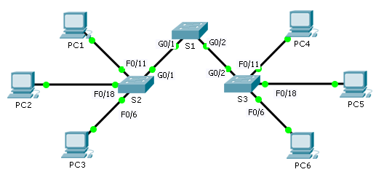

1. Addressing Table

|  |  |  |  |  |  |
| --- | --- | --- | --- | --- | --- |
| Device | Interface | IPv4 Address | Subnet Mask | Switch Port | VLAN |
| PC1 | NIC | 172.17.10.21 | 255.255.255.0 | S2 F0/11 | 10 |
| PC2 | NIC | 172.17.20.22 | 255.255.255.0 | S2 F0/18 | 20 |
| PC3 | NIC | 172.17.30.23 | 255.255.255.0 | S2 F0/6 | 30 |
| PC4 | NIC | 172.17.10.24 | 255.255.255.0 | S3 F0/11 | 10 |
| PC5 | NIC | 172.17.20.25 | 255.255.255.0 | S3 F0/18 | 20 |
| PC6 | NIC | 172.17.30.26 | 255.255.255.0 | S3 F0/6 | 30 |

Objectives

Part 1: Test Connectivity between PCs on the Same VLAN

Part 2: Investigate Connectivity Problems by Gathering Data

Part 3: Implement the Solution and Test Connectivity

1. Scenario

In this activity, you will troubleshoot connectivity problems between PCs on the same VLAN. The activity is complete when PCs on the same VLAN can ping each other. Any solution you implement must conform to the Addressing Table.

1. Test Connectivity between PCs on the Same VLAN

From the command prompton each PC, ping between PCs on the same VLAN.

* + 1. Can PC1 ping PC4?
    2. Can PC2 ping PC5?
    3. Can PC3 ping PC6?

1. Investigate Connectivity Problems by Gathering Data
   1. Verify configuration on the PCs.

Based on your knowledge, verify if the following configurations for each PC is correct.

* IP address
* Subnet mask
  1. Verify the configuration on the switches.

Based on your knowledge, verify if the following configurations on the switches are correct.

* Ports assigned to the correct VLANs.
* Ports configured for the correct mode.
* Ports connected to the correct devices.
  1. Document the problem and the solutions.

List the problems and the solutions that will allow these PCs to ping each other. Keep in mind that there could be more than one problem or more than one solution.

PC1 to PC4

* + 1. Explain the connectivity issues between PC1 and PC4.
    2. Record the necessary actions to correct the issues.

PC2 to PC5

* + 1. Explain the connectivity issues between PC2 and PC5
    2. Record the necessary actions to correct the issues.

PC3 to PC6

* + 1. What are the reasons why connectivity failed between the PCs?
    2. Record the necessary actions to correct the issues.

1. Implement the Solution and Test Connectivity

Verify PCs on the same VLAN can now ping each other. If not, continue to troubleshoot.

1. Suggested Scoring Rubric

Packet Tracer scores 70 points. Documentation in Part 2, Step 3 is worth 30 points.